Progress in Fractional Differentiation and Applications
(An International Journal)
Accepted on 24 June 2026
  Title: A Unified Transform Approach for Analyzing Fractional Differential Models with Diverse Fractional Operators
  Authors: Mohd Khalid, SK Ashadul Rahaman, Salman Zaheer, Ausif Padder, Mohamed Hafez, Sudesh Nair Baskara, and Ali Akgul,
  Ref. PFDA062426B
ISSN 2356-9336 (print)
ISSN 2356-9344 (online)
http://dx.doi.org/10.18576/pfda

Indexed in SCOPUS Q2

Published BY
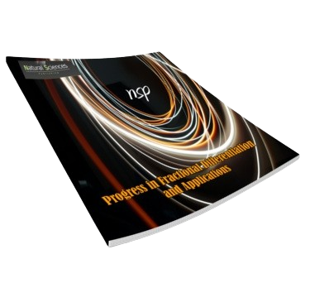
Natural Sciences Publishing

The scope of the PFDA covers all theoretical and experimental aspects of fractional differentiation and related approaches. Reviews, letters and original research articles dealing with topics such as fractional and integral equations, fractional discrete calculus and fractional dynamics are welcome. The original submissions concerning both theoretical and the applications of fractional differentiation in numerical analysis, mathematical analysis, signal analysis, bifurcations, statistics, data analysis, time series analysis, chaos, bioengineering, economics, finance, fractal theory, optics, control systems, artificial intelligence, fractional differential equations with uncertainty, mathematical biology and nanotechnology are encouraged.
We are very pleased to inform you that your paper has been accepted for publication in our journal and will be published in the next upcoming issue.
Your research contribution has added significant value to the field, and we appreciate the effort you have put into this work. The paper has been reviewed by our editorial board and has been accepted based on the high quality of research and new work presented.
To ensure that your paper is published on time, please submit the final version of the manuscript with the required formatting within 5 days.
We look forward to future collaborations and thank you for your contribution.


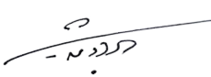

Sincerely,

NSP Chairman and Managing office.
https://www.naturalspublishing.com/Journals.asp
To be considered for publication, your introduction should clearly explain the novelty, urgency and originality of the research in your article. All manuscripts submitted to Information Sciences Letters will be checked for originality using the CrossCheck database. For more information on CrossCheck please visit http://www.crossref.org/crosscheck.html

